Name: **ZOHAIB HASSAN SOOMRO**

RollNo#: **19SW42**

Subject: **DSA**

**Task#1:** Apply linear and binary search algorithm on array of string and characters also print execution time of each result.

**Code:**

public class Task1_ExecutionTime {

public static <E> int linearSearch(E[] array, E target) {

if (array.length == 0)

return -1;

for (int i = 0; i < array.length; i++) {

if (array[i].equals(target))

return i;

}

return -1;

}

public static <E> int binarySearch(E[] array, E target) {

if (array.length == 0)

return -1;

int start=0;

int end=array.length-1;

while (start<=end) {

int mid= (start+end)/2;

if (array[mid].equals(target)) return mid;

else if(array[mid].toString().compareTo(target.toString())<0)

start=mid+1;

else end=mid-1;

}

return -1;

}

public static void main(String[] args) {

// System.currentTimeMillis();

String strArray[] = { "Ali", "Is", "Lover", "Of", "Sara" };

Character charArray[] = {'d', 'e', 'f', 'g' ,'h','i','j'};

long miliSecsStart = System.*nanoTime*();

System.***out***.println("linearSearch(strArray, \"This\") index = " +*linearSearch*(strArray, "This"));

long miliSecsEnd = System.*nanoTime*();

System.***out***.println("linearSearch(strArray, \"This\") Execution time = " + (miliSecsEnd - miliSecsStart)+" ns\n");

miliSecsStart = System.*nanoTime*();

System.***out***.println("linearSearch(charArray, 'i') index = " +*linearSearch*(charArray, 'i'));

miliSecsEnd = System.*nanoTime*();

System.***out***.println("linearSearch(charArray, 'i') Execution time = " + (miliSecsEnd - miliSecsStart)+" ns\n\n");

miliSecsStart = System.*nanoTime*();

System.***out***.println("binarySearch(strArray, \"Lover\") index = " +*binarySearch*(strArray, "Lover"));

miliSecsEnd = System.*nanoTime*();

System.***out***.println("binarySearch(strArray, \"Lover\") Execution time = " + (miliSecsEnd - miliSecsStart)+" ns\n");

miliSecsStart = System.*nanoTime*();

System.***out***.println("binarySearch(charArray, 'i') index = " + *binarySearch*(charArray, 'i'));

miliSecsEnd = System.*nanoTime*();

System.***out***.println("binarySearch(charArray, 'i') Execution time = " + (miliSecsEnd - miliSecsStart)+" ns");

}

}^

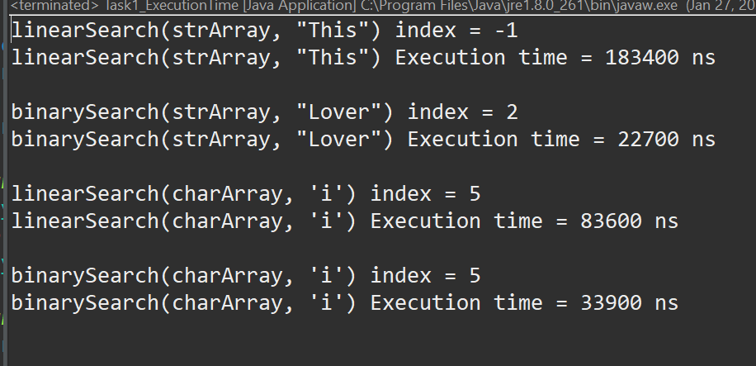

**Task#2:** Apply linear and binary search algorithm on an array of any user defined object of your type.

**Code:**

class MyRectangle implements Comparable {

int area;

public MyRectangle(int length, int width) {

area = length * width;

}

*@Override*

public int compareTo(Object obj) {

if (this.area < (int) obj)

return -1;

if (this.area > (int) obj)

return 1;

return 0;

}

*@Override*

public boolean equals(Object obj) {

return (compareTo(obj) == 0);

}

}

public class Task2_UserDefined {

public static int linearSearch(MyRectangle[] array, int target) {

if (array.length == 0)

return -1;

for (int i = 0; i < array.length; i++) {

if (array[i].equals(target))

return i;

}

return -1;

}

public static int binarySearch(MyRectangle[] array, int target) {

if (array.length == 0)

return -1;

int start = 0;

int end = array.length - 1;

while (start <= end) {

int mid = (start + end) / 2;

if (array[mid].equals(target))

return mid;

else if (array[mid].compareTo(target) < 0)

start = mid + 1;

else

end = mid - 1;

}

return -1;

}

public static void main(String[] args) {

MyRectangle rectangles[] = new MyRectangle[6];

for (int i = 0; i < rectangles.length; i++) {

rectangles[i] = new MyRectangle(i + 4, i + 5); // area=20,30,42,58,72,90

}

System.***out***.println("Index of rectangle having area= 42 using... \nbinarySearch(rectangles,42): "

+ *binarySearch*(rectangles, 42));

System.***out***.println("\n\nIndex of rectangle having area= 56 using... \nlinearSearch(rectangles,56): "

+ *linearSearch*(rectangles, 56));

System.***out***.println("\n\nIndex of rectangle having area= 57 using... \nbinarySearch(rectangles,57): "

+ *binarySearch*(rectangles, 57));

}

}

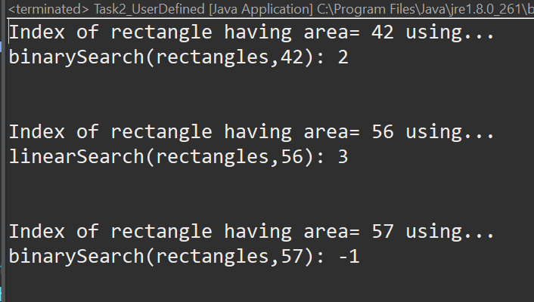

**Task#3:** Apply linear and binary search algorithm on a 2-D integer array (+1 marks).

**Code:**

import java.util.Arrays;

public class Task3_2DSearch {

public static int[] linearSearch(int[][] array, int target) {

if (array.length == 0)

throw new NullPointerException("Array has no element!");

int index[] = { -1, -1 };

for (int i = 0; i < array.length; i++) {

for (int j = 0; j < array[i].length; j++) {

if (array[i][j] == (target)) {

index[0] = i;

index[1] = j;

return index;

}

}

}

return index;

}

public static int[] binarySearch(int[][] array, int target) {

if (array.length == 0)

throw new NullPointerException("Array has no element!");

int into1DArray[] = new int[array.length * array[0].length];

for (int i = 0; i < array.length; i++) {

System.*arraycopy*(array[i], 0, into1DArray, i * array[i].length, array[i].length);

}

int start = 0;

int end = into1DArray.length - 1;

while (start <= end) {

int mid = (start + end) / 2;

if (into1DArray[mid] == target) {

int indices[] = { mid / array[0].length, mid % array[0].length };

return indices;

} else if (into1DArray[mid] < target)

start = mid + 1;

else

end = mid - 1;

}

return new int[] { -1, -1 };

}

public static void main(String[] args) {

int[][] array = { { 1, 2, 3 }, { 4, 5, 6 }, { 7, 8, 9 } };

int target = 5;

System.***out***.println("Whole 2D-Array: ");

for (int i = 0; i < array.length; i++) {

System.***out***.println(Arrays.*toString*(array[i]));

}

int indices[] = *linearSearch*(array, target); // as there willbe two indexes

System.***out***

.println("Index of " + target + " using linearSearch algorithm = [" + indices[0] + "][" + indices[1] + "]");

target = 7;

indices = *binarySearch*(array, target);

System.***out***

.println("Index of " + target + " using binarySearch algorithm = [" + indices[0] + "][" + indices[1] + "]");

}

}

